**CS641 Adv. Computer Networks: Client Server performing multiplication in C**

**Anish Doshi (ap2326) 12/11/2018**

Code: *Server.c*

#include <stdio.h>

#include <stdlib.h>

#include <string.h>

#include <unistd.h>

#include <sys/types.h>

#include <sys/socket.h>

#include <netinet/in.h>

#include <ctype.h>

void error(const char *msg)

{

perror(msg);

exit(1);

}

int main(int argc, char *argv[])

{

int sockfd, newsockfd, portno, n;

socklen_t clilen;

char buffer[1024];

struct sockaddr_in serv_addr, cli_addr;

if (argc < 2) {

fprintf(stderr,"ERROR!, port number absent\n");

exit(1);

}

sockfd = socket(AF_INET, SOCK_STREAM, 0); //socket file descriptor created

if (sockfd < 0)

error("ERROR! for opening socket");

bzero((char *) &serv_addr, sizeof(serv_addr)); //socket strut initialization

portno = atoi(argv[1]);

serv_addr.sin_family = AF_INET;

serv_addr.sin_addr.s_addr = INADDR_ANY;

serv_addr.sin_port = htons(portno);

if (bind(sockfd, (struct sockaddr *) &serv_addr, sizeof(serv_addr)) < 0) //bind the host

error("ERROR! for binding");

listen(sockfd,3); //listen and wait for connections

clilen = sizeof(cli_addr);

newsockfd = accept(sockfd, (struct sockaddr *) &cli_addr, &clilen);

if (newsockfd < 0)

error("ERROR! for accepting");

int n1 , n2 , ans , cont;

R: n = write(newsockfd,"Enter Number 1 : ",strlen("Enter Number 1")); //ask client for number 1

if (n < 0) error("ERROR! for writing to socket");

read(newsockfd, &n1, sizeof(int));

printf("Client says: Number 1 is : %d\n" , n1); //display number 1 given by client

n = write(newsockfd,"Enter Number 2 : ",strlen("Enter Number 2")); //ask client for number 2

if (n < 0) error("ERROR! for writing to socket");

read(newsockfd, &n2, sizeof(int));

printf("Client says: Number 2 is : %d\n" , n2); //display number 2 given by client

ans = n1*n2;

write(newsockfd , &ans , sizeof(int)); //respond the client with multiplication of two numbers

n = write(newsockfd,"Repeat? Press 1 to Continue 0 to Exit: ",strlen("Repeat? Press 1 to Continue 0 to Exit: ")); //ask if client wants to continue or exit

if (n < 0) error("ERROR! for writing to socket");

read(newsockfd, &cont, sizeof(int));

printf("Repeat? continue-1 / exit-0 : %d\n" , cont);

if(cont==1)

goto R;

close(newsockfd);

close(sockfd);

return 0;

}

Code: *Client.c*

#include <stdio.h>

#include <stdlib.h>

#include <unistd.h>

#include <string.h>

#include <sys/types.h>

#include <sys/socket.h>

#include <netinet/in.h>

#include <netdb.h>

#include<ctype.h>

void error(const char *msg) //error message

{

perror(msg);

exit(0);

}

int main(int argc, char *argv[])

{

int sockfd, portno, n;

struct sockaddr_in serv_addr;

struct hostent *server;

char buffer[1024];

if (argc < 3)

{

fprintf(stderr,"Usage %s hostname port\n", argv[0]);

exit(0);

}

portno = atoi(argv[2]);

sockfd = socket(AF_INET, SOCK_STREAM, 0); //socket file descriptor created

if (sockfd < 0)

error("ERROR! for opening socket\n");

server = gethostbyname(argv[1]);

if (server == NULL) {

fprintf(stderr,"ERROR! no such host\n");

exit(0);

}

bzero((char *) &serv_addr, sizeof(serv_addr));

serv_addr.sin_family = AF_INET;

bcopy((char *)server->h_addr,(char *)&serv_addr.sin_addr.s_addr,server->h_length);

serv_addr.sin_port = htons(portno);

if (connect(sockfd,(struct sockaddr *) &serv_addr,sizeof(serv_addr)) < 0) //connection to the server

error("ERROR! for connecting\n");

int n1, n2, ans, cont;

R: bzero(buffer,256);

n = read(sockfd,buffer,255); //messgae for input number 1

if (n < 0)

error("ERROR! for reading from socket\n");

printf("Server says: %s\n",buffer);

scanf("%d" , &n1);

write(sockfd, &n1, sizeof(int)); //accept number 1 and send to server

bzero(buffer,256);

n = read(sockfd,buffer,255); //messgae for input number 2

if (n < 0)

error("ERROR! for reading from socket\n");

printf("Server says: %s\n",buffer);

scanf("%d" , &n2);

write(sockfd, &n2, sizeof(int)); //accept number 2 and send to server

read(sockfd , &ans , sizeof(int)); //result from server

printf("Server says: The multiplication product is: %d\n" , ans);

bzero(buffer,256);

n = read(sockfd,buffer,255); //messgae for continuing

if (n < 0)

error("ERROR! for reading from socket\n");

printf("Server says: %s\n",buffer);

scanf("%d" , &cont);

write(sockfd, &cont, sizeof(int)); //accept yes/no and send to server

if(cont!=0)

goto R;

printf("\n Thank you. You may now close the terminal.\n");

close(sockfd);

return 0;

}

Output: Screen shot

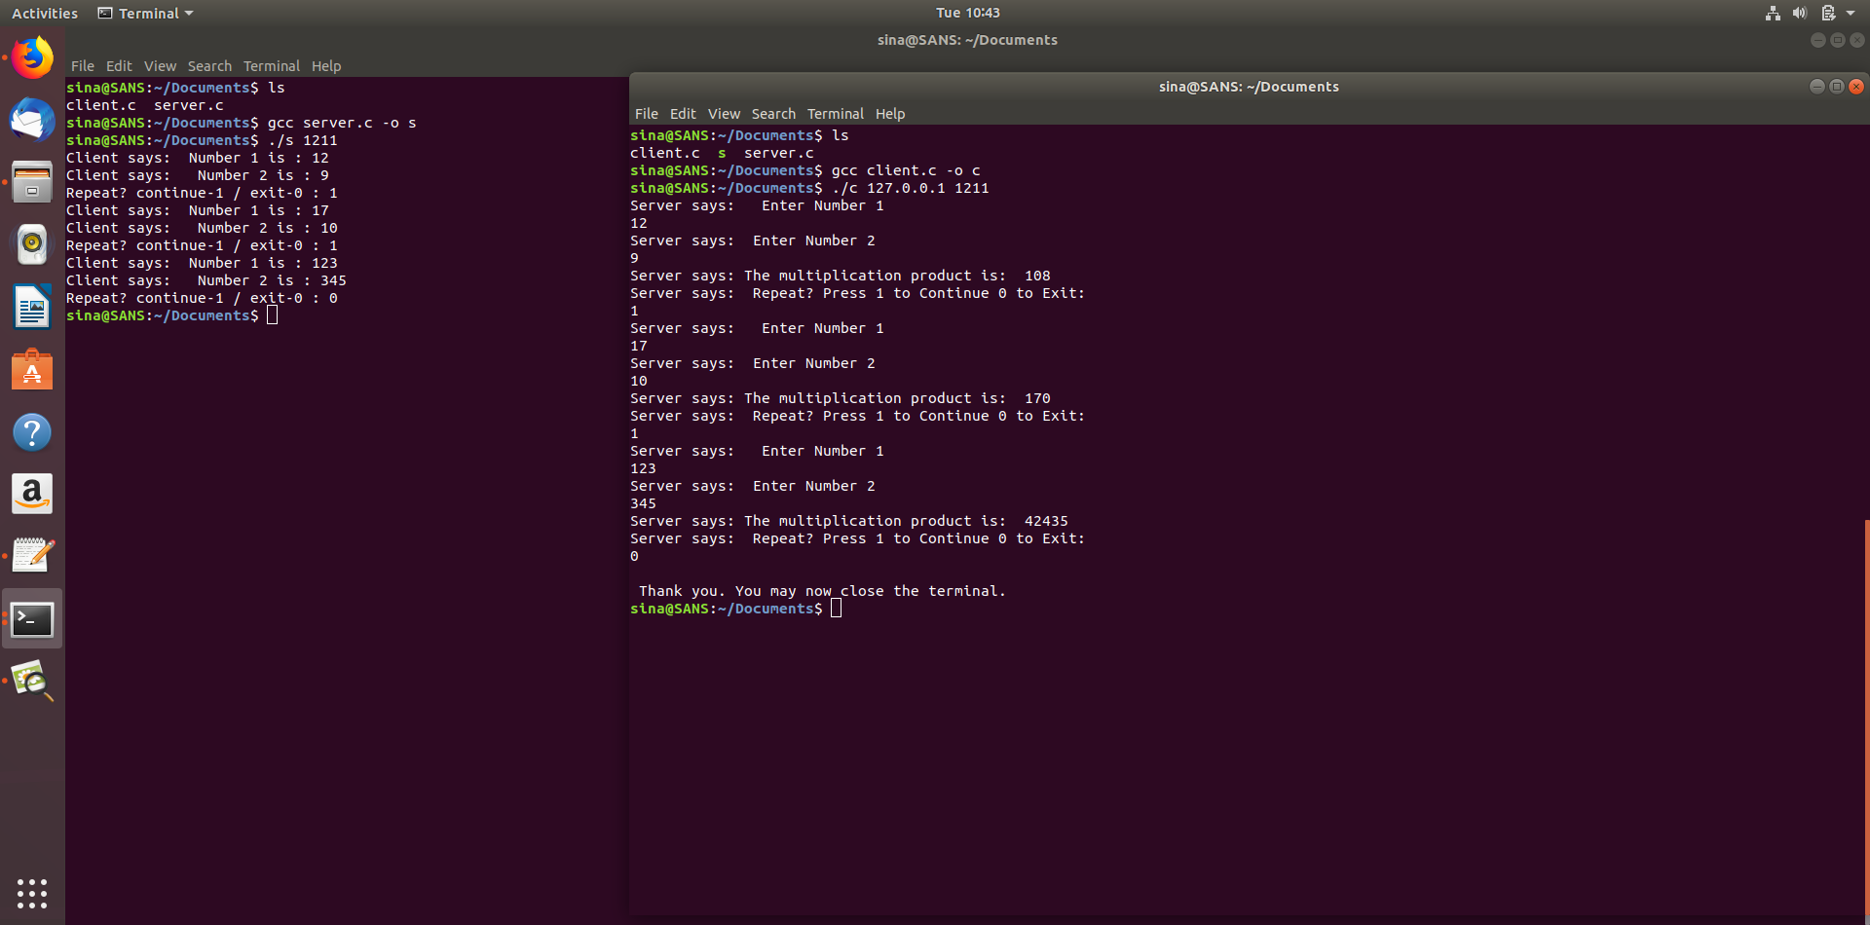

Output: Client Terminal

sina@SANS:~$ cd Documents/  
sina@SANS:~/Documents$ gcc client.c -o client  
sina@SANS:~/Documents$ ./client 127.0.0.1 1211  
Server says:   Enter Number 1  
12  
Server says:  Enter Number 2  
9  
Server says: The multiplication product is:  108  
Server says:  Repeat? Press 1 to Continue 0 to Exit:   
1  
Server says:   Enter Number 1  
17  
Server says:  Enter Number 2  
10  
Server says: The multiplication product is:  170  
Server says:  Repeat? Press 1 to Continue 0 to Exit:   
1  
Server says:   Enter Number 1  
234  
Server says:  Enter Number 2  
456  
Server says: The multiplication product is:  106704  
Server says:  Repeat? Press 1 to Continue 0 to Exit:   
0  
  
Thank you. You may now close the terminal.  
sina@SANS:~/Documents$

Output: Server Terminal

sina@SANS:~/Documents$ gcc server.c -o server  
sina@SANS:~/Documents$ ./server 1211  
Client says:  Number 1 is : 12  
Client says:   Number 2 is : 9  
Repeat? continue-1 / exit-0 : 1  
Client says:  Number 1 is : 17  
Client says:   Number 2 is : 10  
Repeat? continue-1 / exit-0 : 1  
Client says:  Number 1 is : 234  
Client says:   Number 2 is : 456  
Repeat? continue-1 / exit-0 : 0  
sina@SANS:~/Documents$ ^C  
sina@SANS:~/Documents$

--X--